**Handling Numerical Features (Gaussian NB):**

Till now we haven’t seen how NB works with numerical feature.

So now let’s take an example.

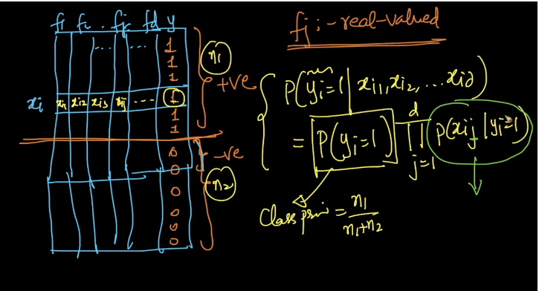

So here as we can see in above image we have d features and a class label y.

When we studied NB eq. there was no limitation to type of feature.

So the eq. should work fine here also and in eq. finding P(Y = 1) is easy but challenging part is calculating P(Xij |Yi = 1)

Now since we are given Yi = 1 so in our training data with class label as 1 we need to find P(Xij) and let’s say the train data with only Y = 1 as D-dash

Now for given set of value i.e. Fj we can plot a PDF for it and determine exact value of probability.

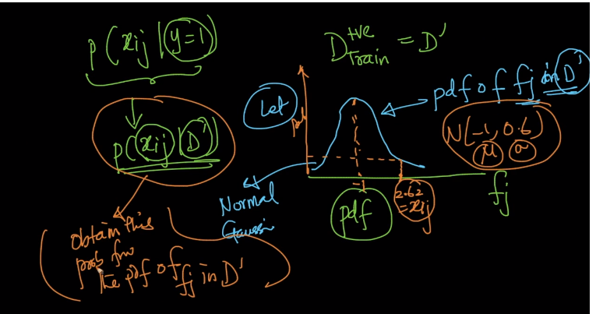

So now let’s say value of Xij is some numerical value say 2.62 so we need to find the value of probability score for 2.62 in our PDF.

And in same way we can calculate all of our likelihoods.

And same thing we can do for Y = 0 but taking only part of training data where class label is y = 0.

Now many people do make assumptions regarding D-dash and D-double dash.

They consider them to Gaussian distributed with significant value of mean and standard deviation.

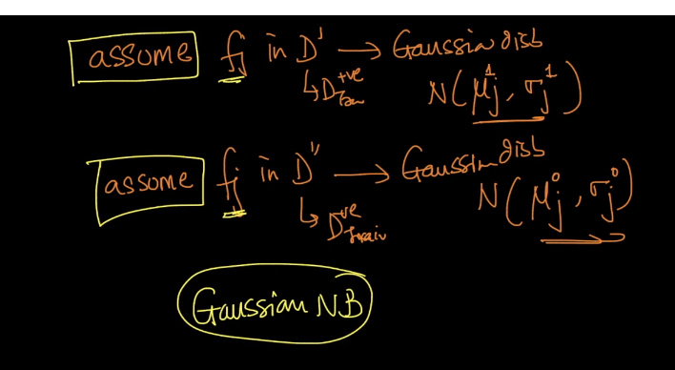

Such a model which made by making this assumption is call “**Gaussian NB”**.

This assumption can be any distribution and so would be the name.

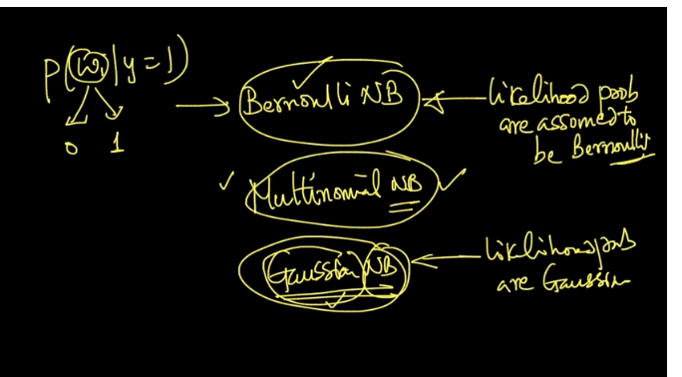

Comments:

